**QUESTION-4**

**Personal data analysis on marital status, existing loans, education, profession etc. and its impact on the campaign’s success.**

**Output1:**

**Analysis on marital status:**

Based on responses:

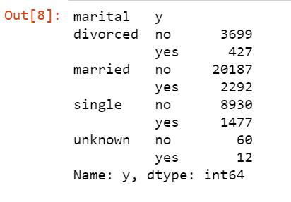

Based on poutcome:

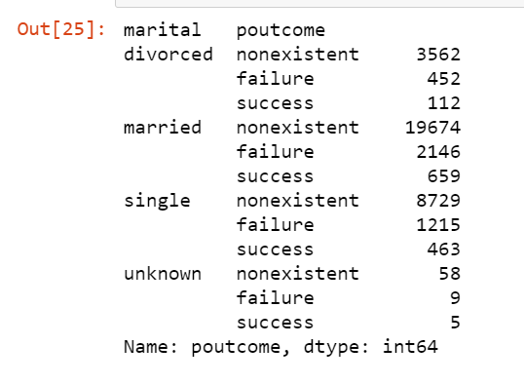

Finding the percentage for martial status Analysis:

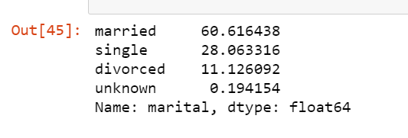

**Output2:**

**Analysis on Existing Loans:**

Based on responses:

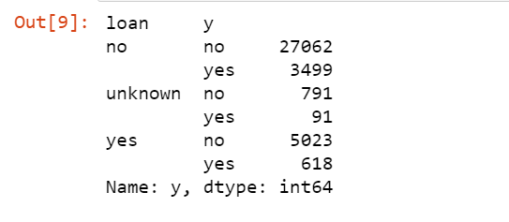

Based on poutcome:

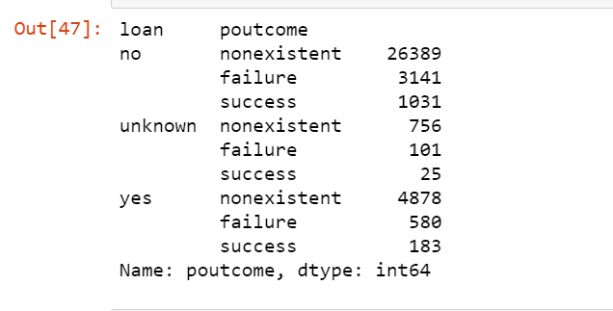

Finding the percentage for Existing Loans Analysis:



**Output3:**

**Analysis on Education:**

Based on responses:

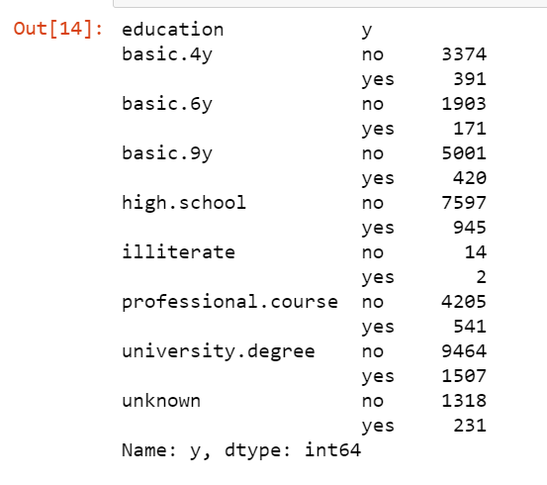

Based on poutcome:

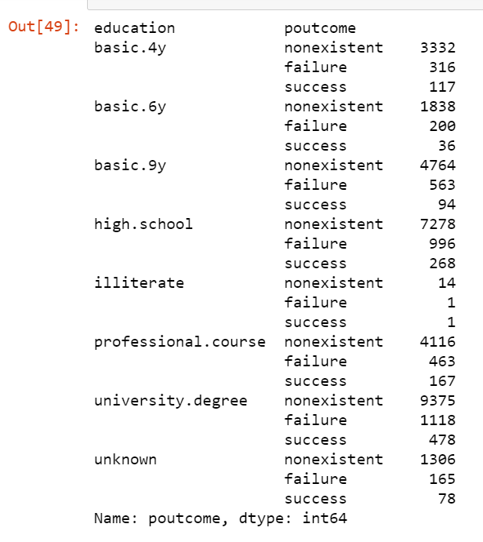

Finding the percentage for Education Analysis:

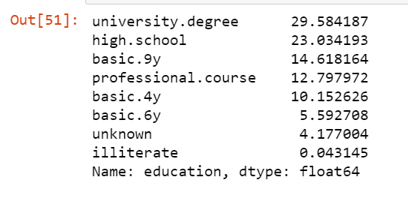

**Output4:**

**Analysis on Profession:**

Based on responses:

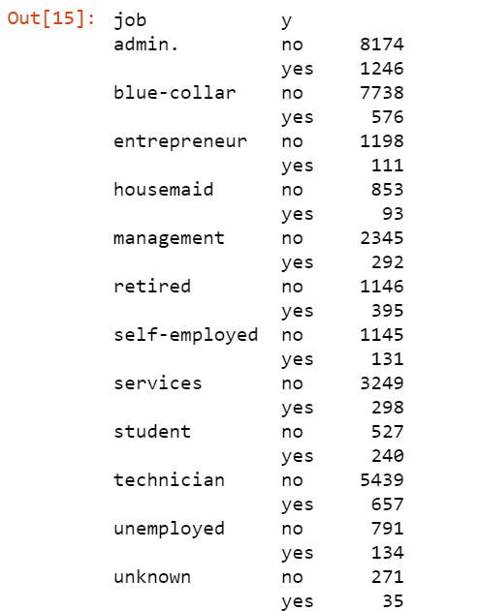

Based on poutcome:

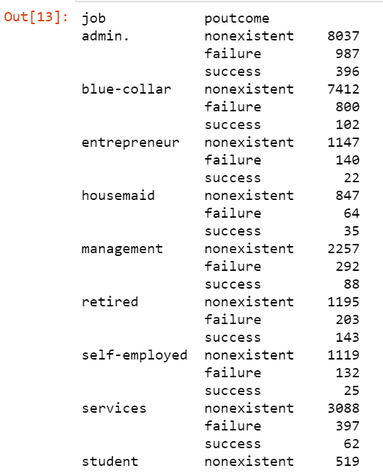

Finding the percentage for job Analysis:

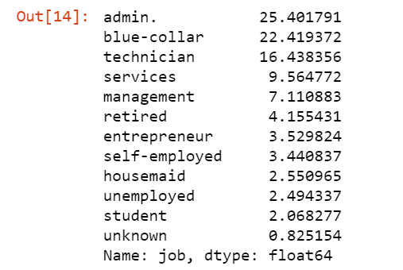

**Output5:**

**Analysis on Housing:**

Based on responses:

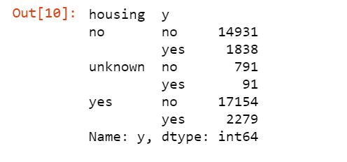

Based on poutcome:

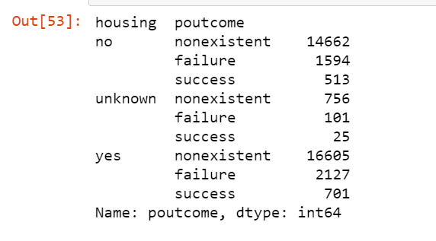

Finding the percentage for housing Analysis:

